- Login/sign up page (remember me function included)
- Homepage for the game with a side section for login/sign up and other features
- Availability of playing without needing a sign-up
- Database of each player saved in the server database for history of games. That is, store the database(Move history of the game played stored in the database with separate folders for each user.(store the database in the folder of the user who wins the game with maximum points – only one player of the team).
- Play online v/s play computer sections
- Limiting the numbers of times a player can forfeit a turn which can be played in the game: A player can forfeit a maximum of 3 times.(Excluding cases when the player cannot move and the game automatically forfeits his turn).
- Check the error (If exists in the chaturanga version 1.0.2) that minor pieces are able to capture minor pieces(nara/pawn,danti/elephant,ashwa/horse can capture each other) and major pieces can capture any piece(Major pieces Ratha,King/raja)
- Enable Focus mode (A function feature beside the board which places the board on the center of the website like:

Before focus mode:
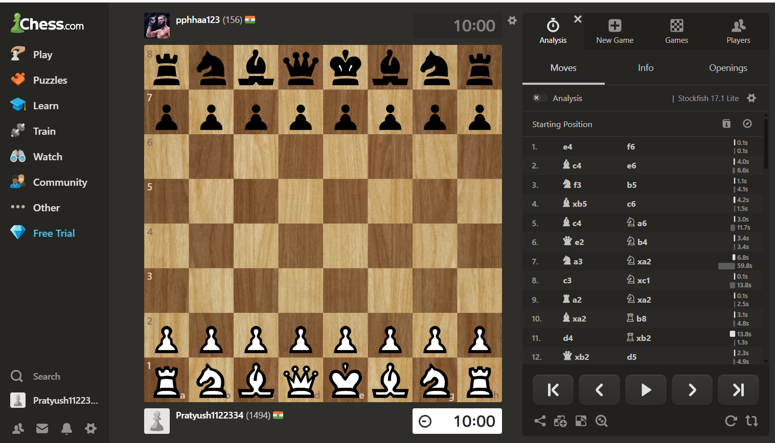

After Focus mode:
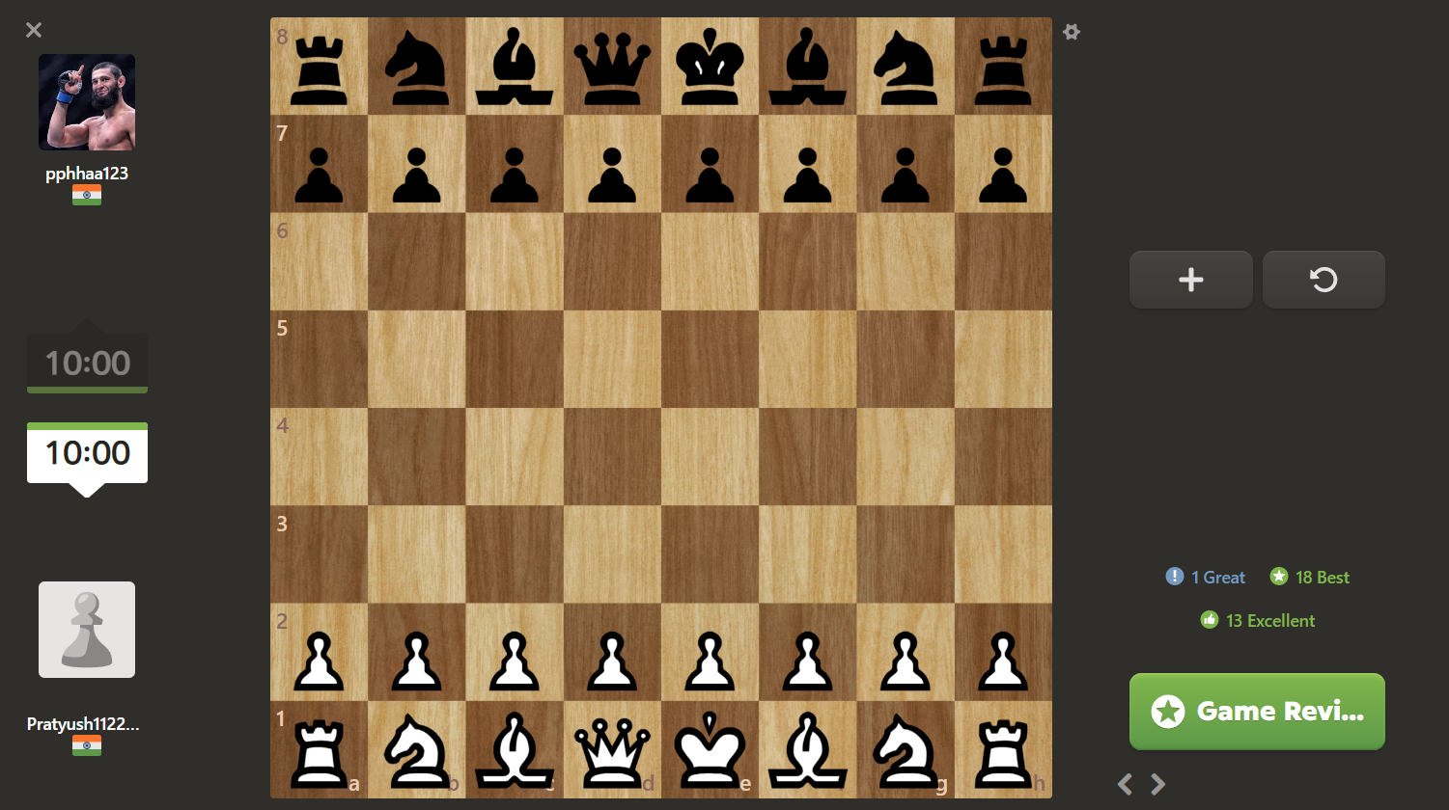

Like above, only the board game and is visible beside the name of the players. You don’t have to implement the other features like clock and profile picture , but instead, the die roll number appeared, and the players piece captured.
- From the same above, board can be resized. (Convert static size of the board into dynamic size of the board).

For making the chaturanga game playing bot, we use the similar concept of a chess bot.
But the twist lies in the fact:

- We use the rules of chaturanga game
- We consider and accept the fact that there are 4 players in chaturanga compared to chess which has only 2 players.
- Consider the forced move from the dice roll.
- There could be a situation of 1,2,3 bots playing the game(but the team up concept of chaturanga remains the same).
Case 1: When 1 bot plays, 3 human players will play the game and one of that bot will be in the team of a human player if it is a team up game. Else, if it is 1vs1vs1vs1, bot will compete against 3 human players
Case 2: When 2 bots play, 2 of them will be in one team(In the team up version of the game) and individually in the 1vs1vs1vs1.
Case 3: When 3 bots play, 2 of them will be in one team(In the team up version of the game) and the 3rd bot will be in the team of a human player( In that case, the human will get to chose the color -blue,green,red and yellow).
Else, individually in the 1vs1vs1vs1.

Special case: Only for the administrator or owner of the game(we) to gather game database when all the 4 players will be bot playing against each other and playing with the algorithms feeded: multiplayer minimax,alpha beta pruning, Monte carlo tree search,expectiminimax, Reinforcement Learning (Q-Learning / Deep Q-Learning), Policy Gradient / Actor-Critic (Advanced RL).

Take the assistance or guide help (hint) from the random move generator doc file in the chaturanga version 1.0.3 folder. Even if possible, Make a simple game engine that is functional for all the above cases. Make a separate folder of codes and planning for all the above changes and modification in the new version. Don’t change the code or files of previous versions, but copy the game structure from chaturanga version 1.0.2 . Don’t crash the backend and apply all the necessay logic in backend and frontend. The changes mentioned in the new features.docx file .

